**NAME : DHARSHINI.B.S**

**REG.NO : 16MIS0449**

**COURSE TITLE : AMAZON WEB SERVICE**

**GUIDED BY : ETHNUS**

**UNIVERSITY**



1. **Demo class- AWS**

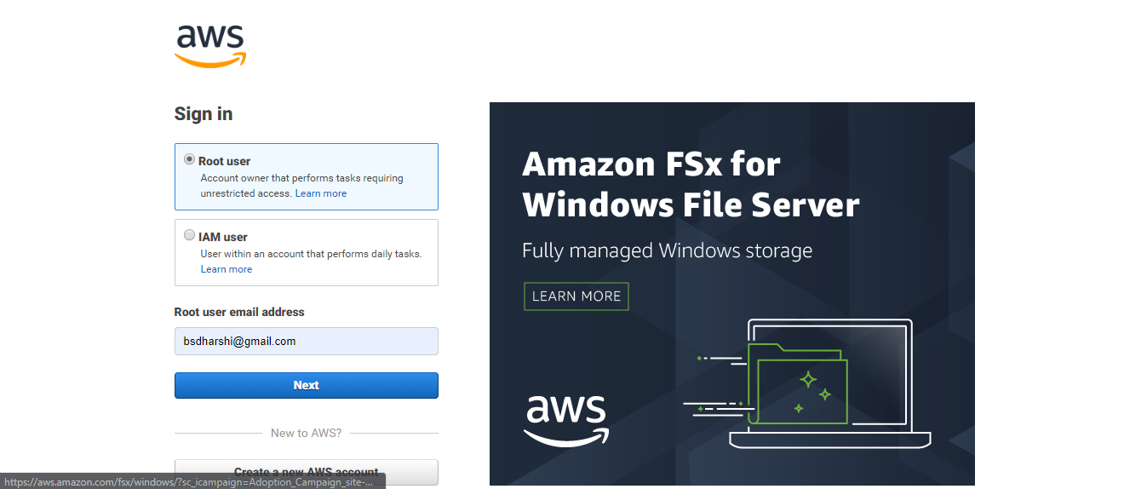

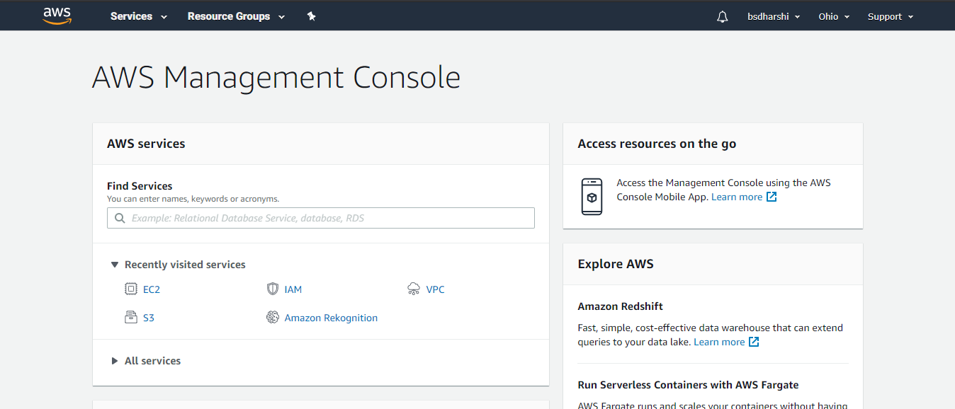

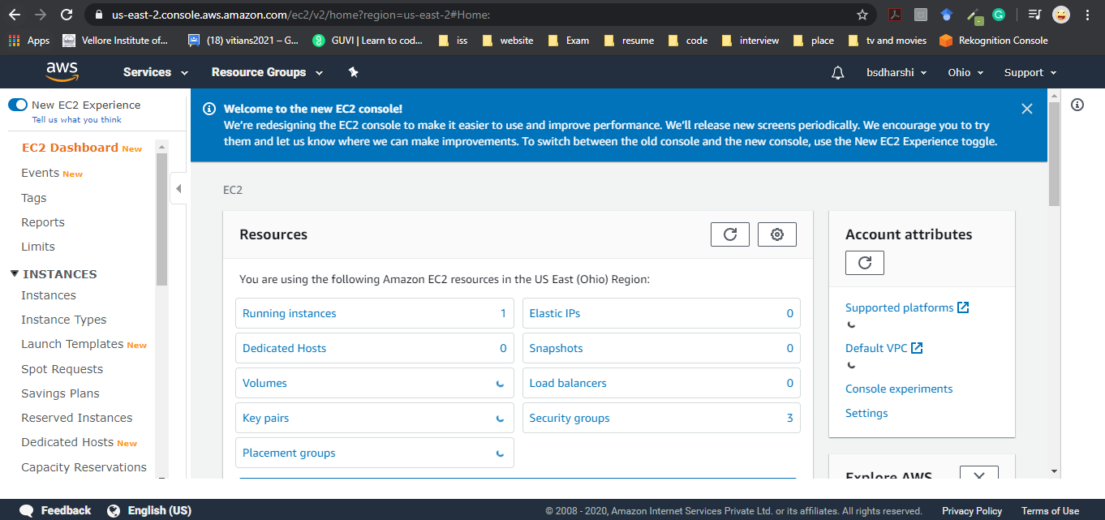

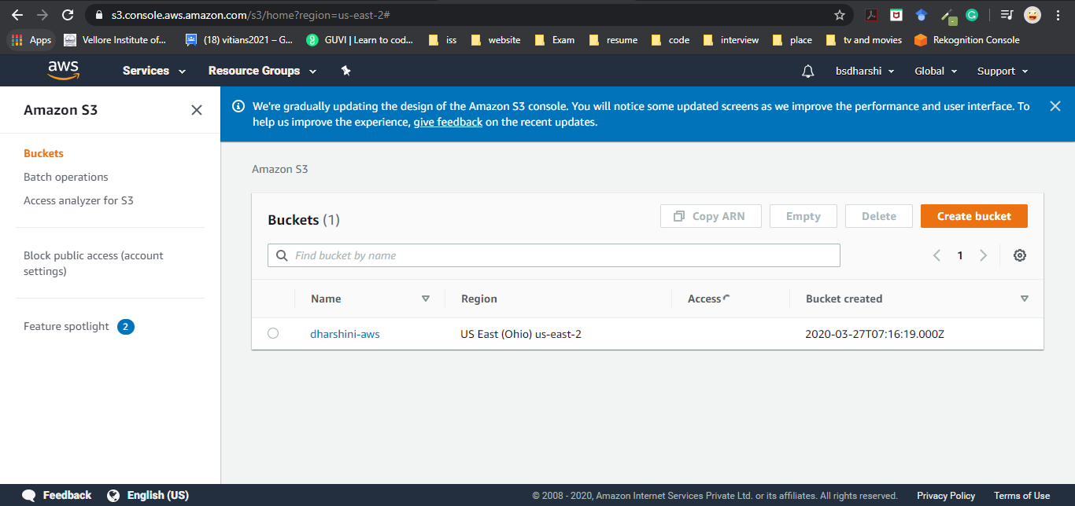

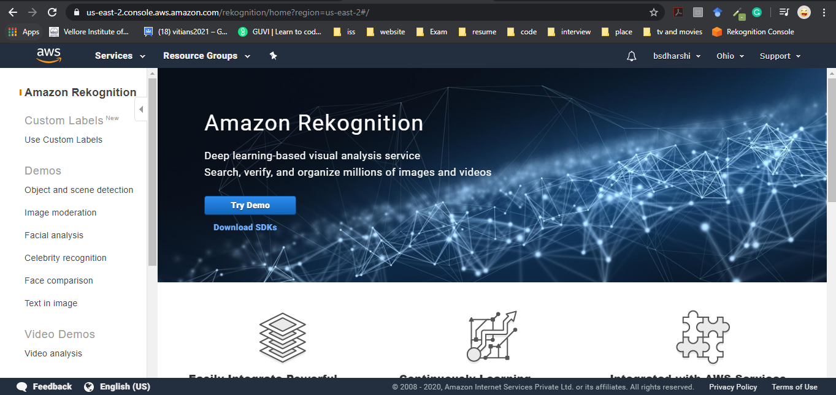

1. **Master class Day -1 EC2**

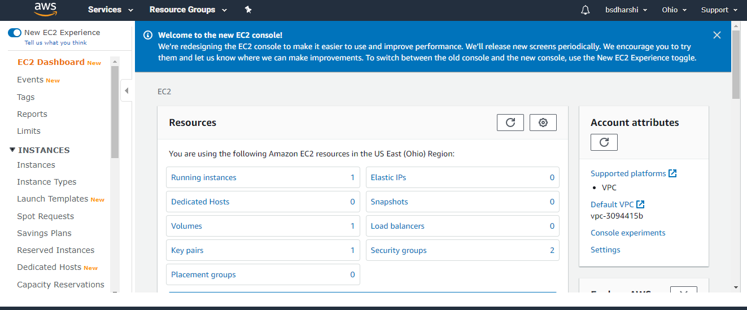

Step: 1- Select the operating System.

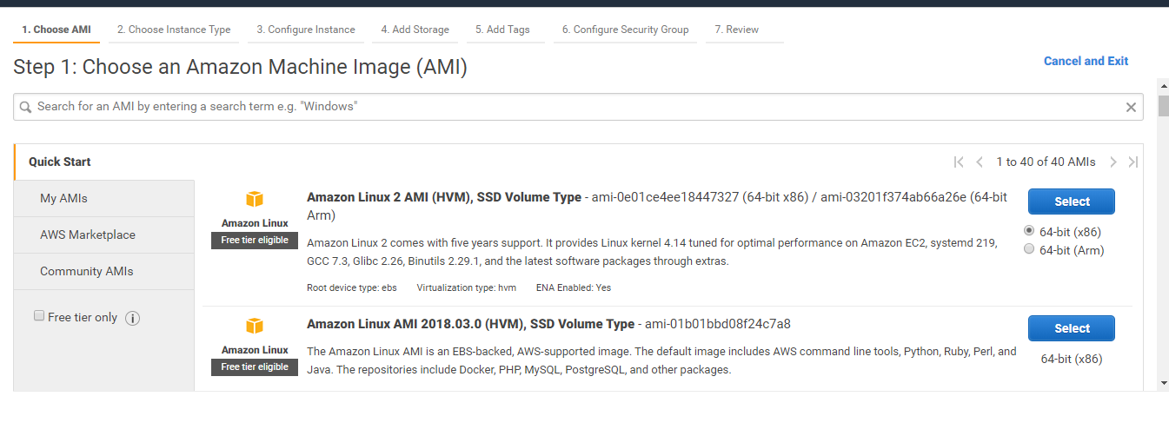

Step: 2 Select t2 micro.

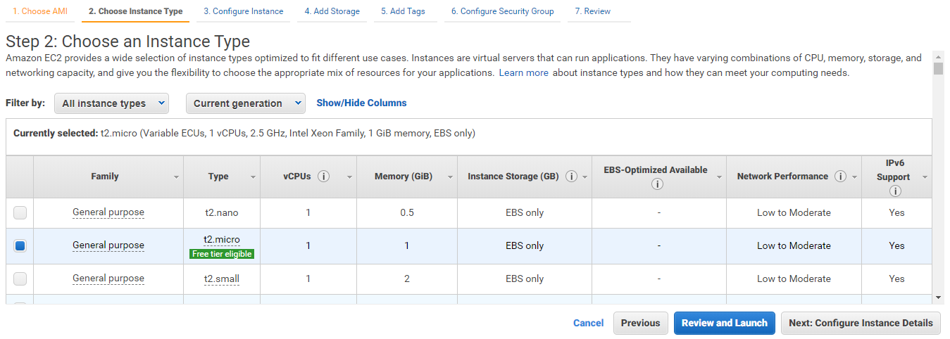

Step: 3

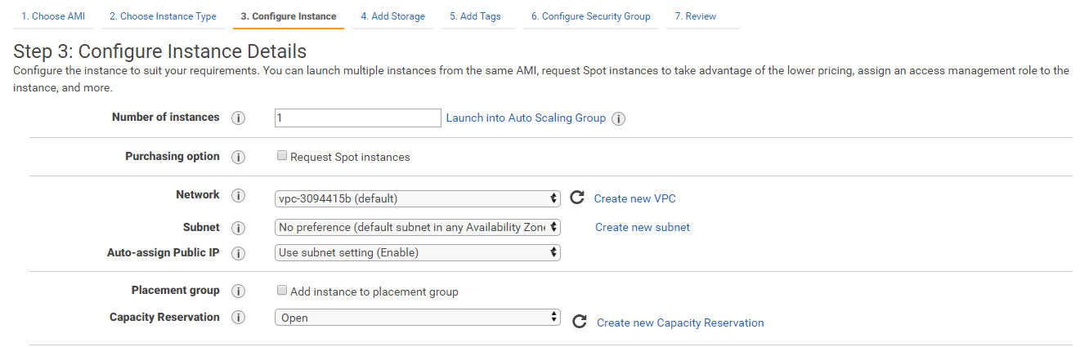

Step: 4 Add 8 GB storage.

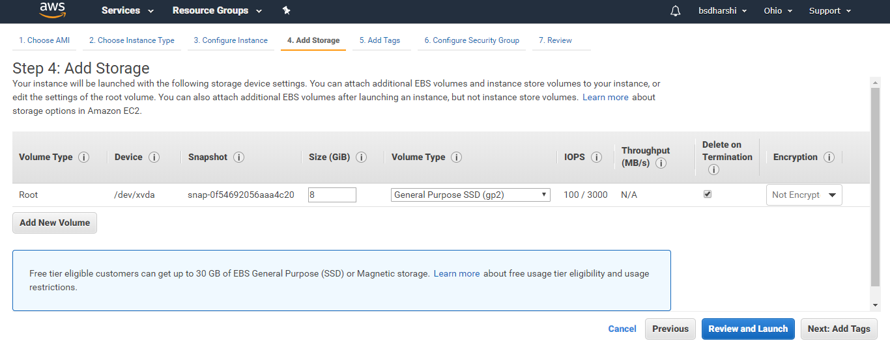

Step: 5

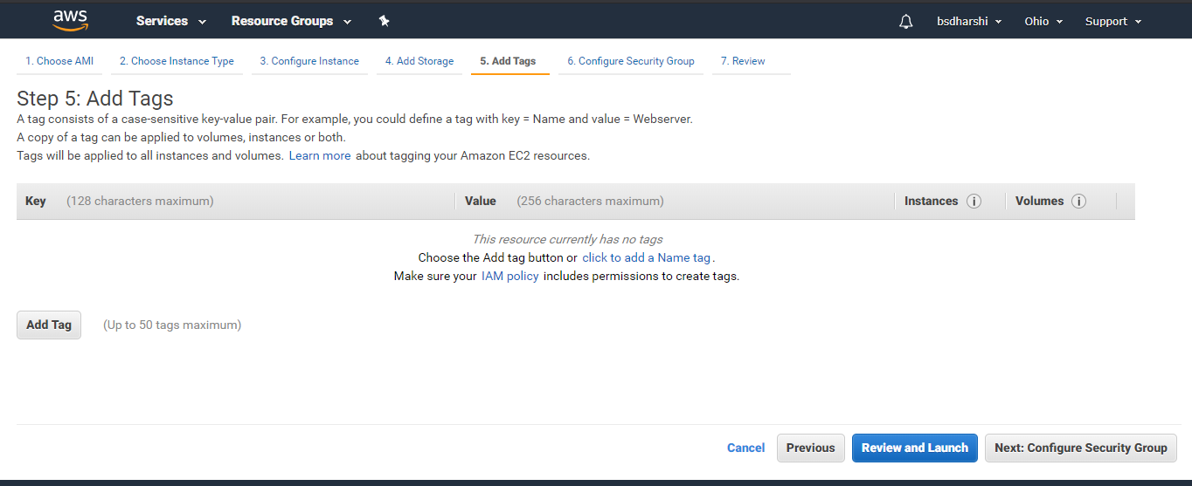

Step: 6 Security group.

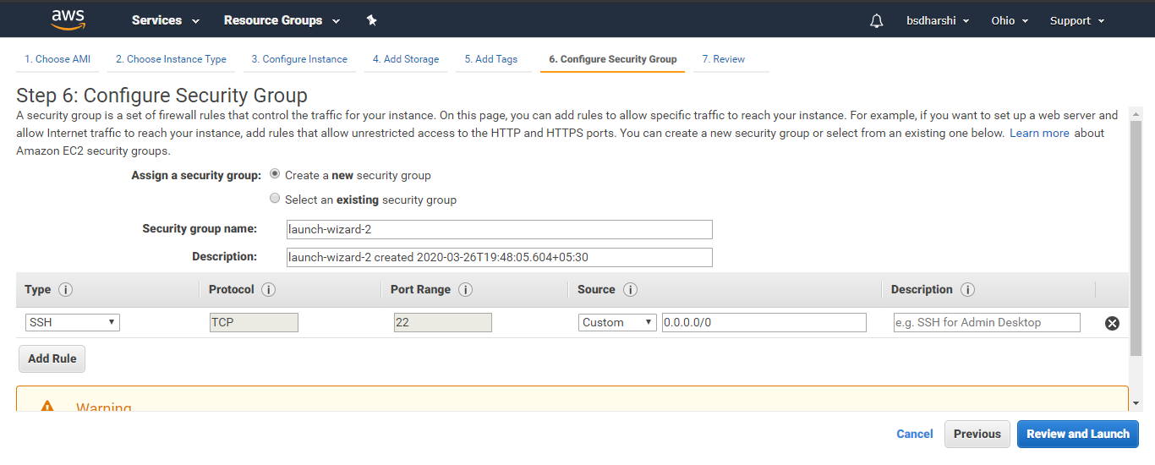

Step: 7 Launch the instance.

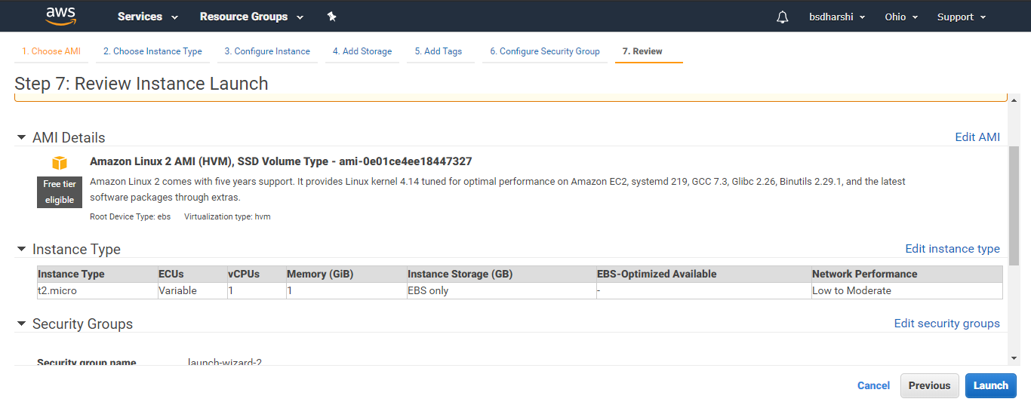

Step: 8 Enter the key pair name and download it. It will in .pem format.

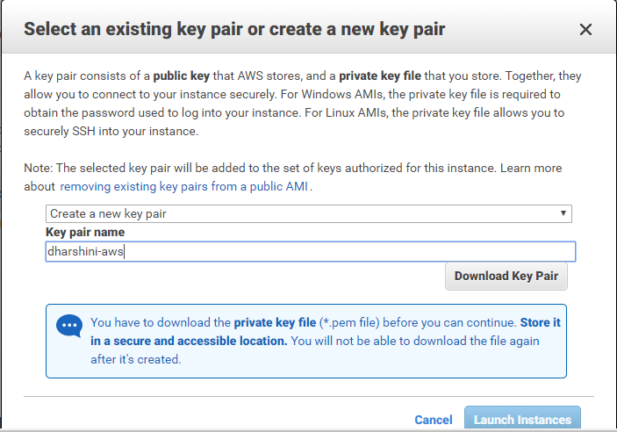

Step: 9 Instance created.

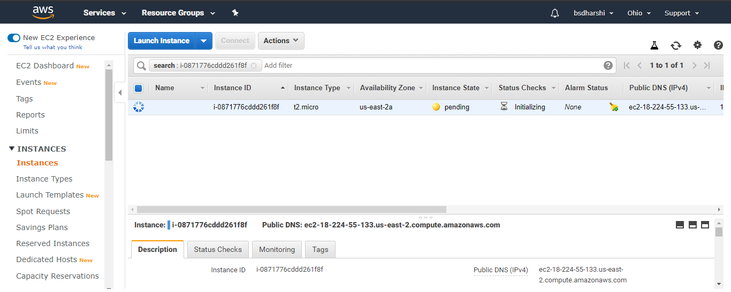

Step: 10 In command prompt convert the .pem file format to .ppk format. Since puTTY accept only .ppk

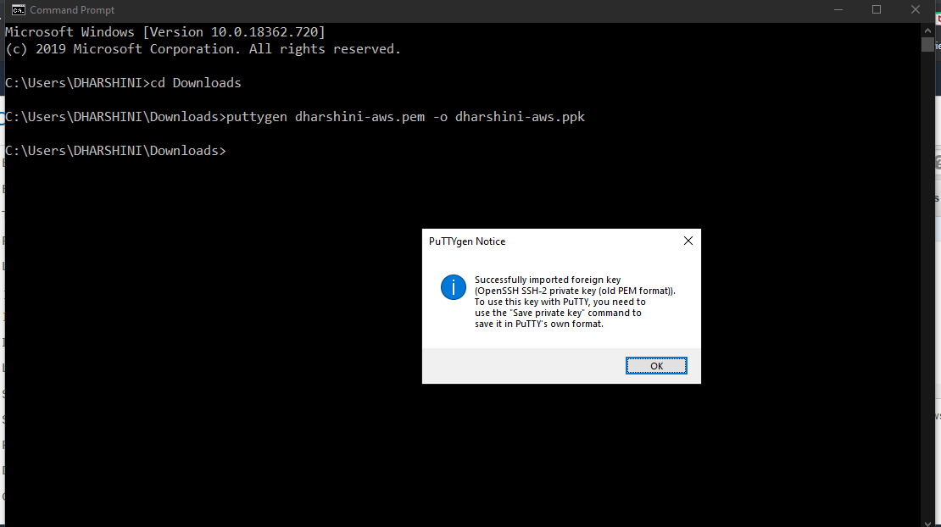

Step: 11 Paste the IP address and SSH – 22 Port.

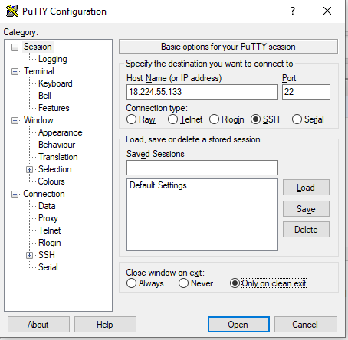

Step: 12 Paste the converted private key file.

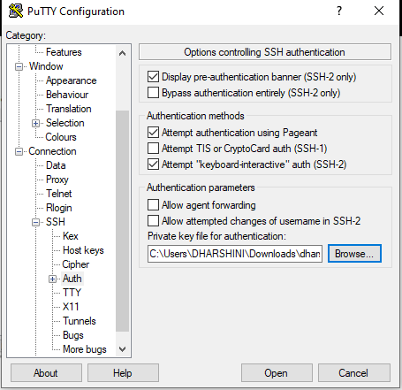

Step: 13 puTTY command prompt.

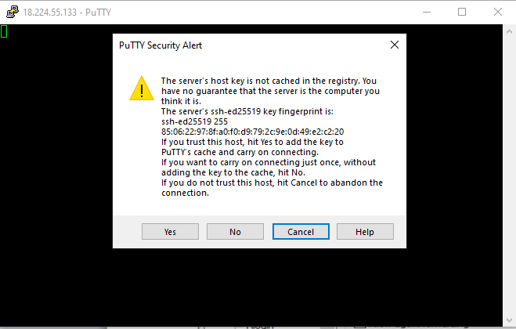

Step: 14 Login using ec2-user name.

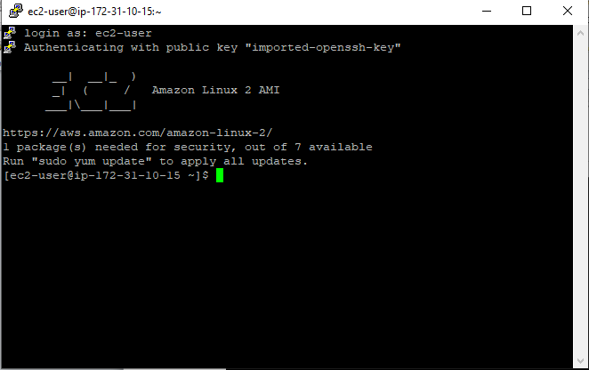

Step: 15 enter sudo yum install httpd command and press y.

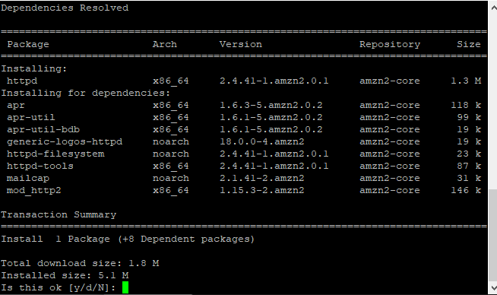

Step: 16 Enter the commands sudo service httpd start and sudo service httpd status.

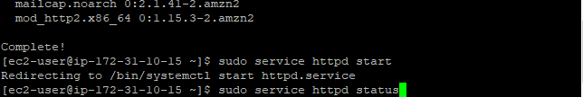

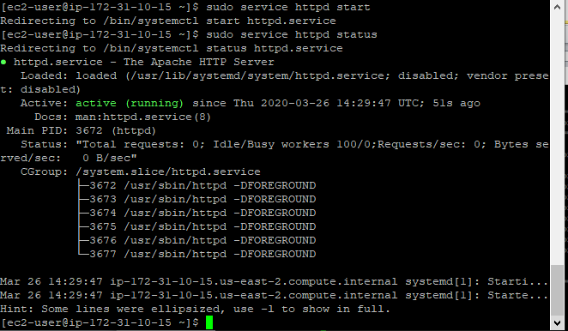

Step: 17 Then press i and type the sentence as your wish and press escape and type :wq and press enter.

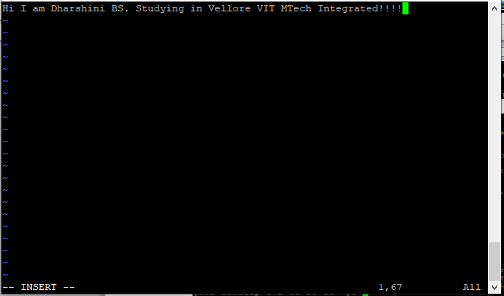

Step: 18 Edit the inbound and add http and source as anywhere.

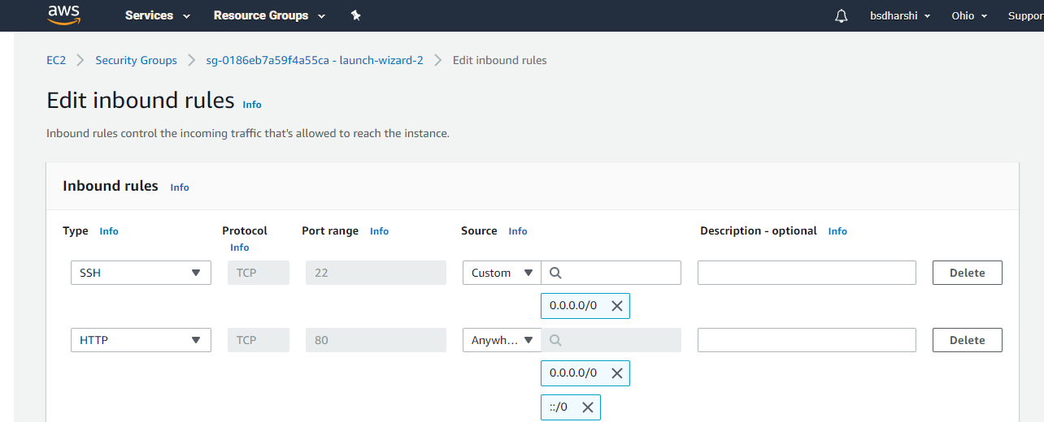

Step: 19 Then the instance can be accessed.

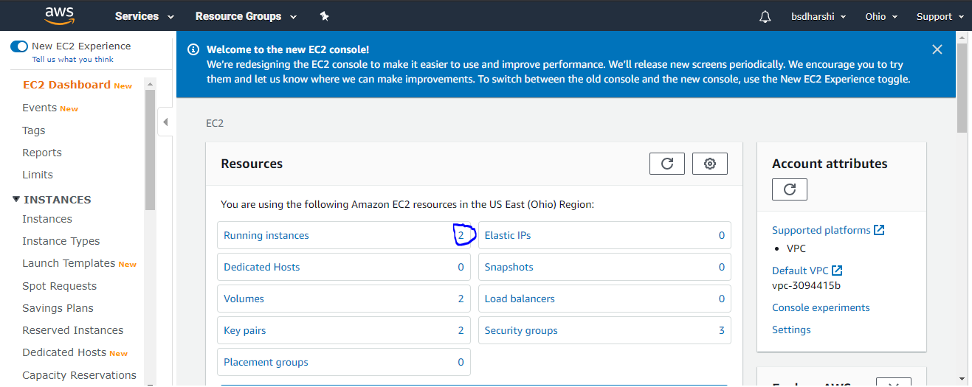

Step: 20 This is the webpage.

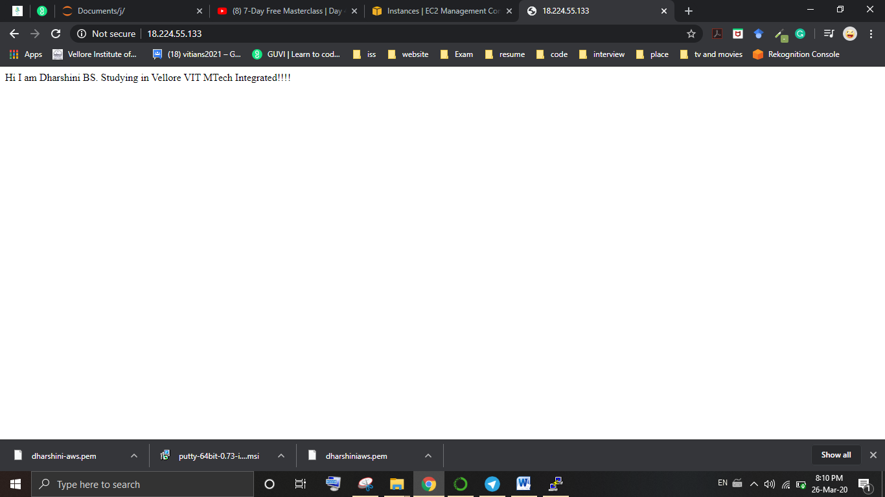

1. **Day2-S3**

Step: 1 Enter into S3 service and create the bucket.

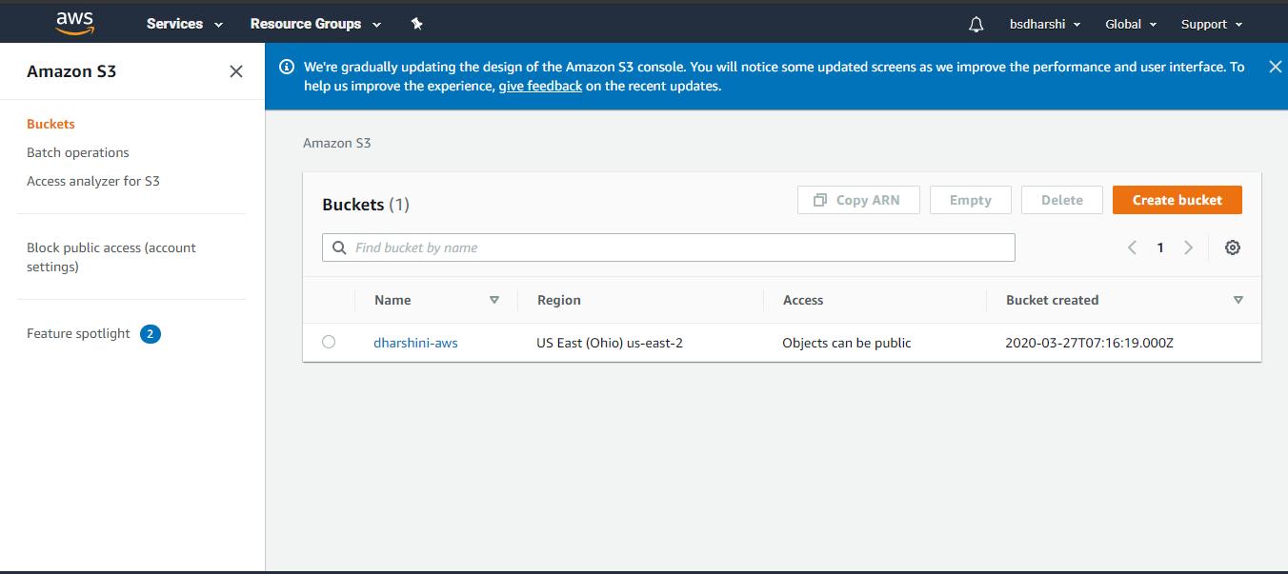

Step: 2 Then in the bucket upload the file in html format and set permission

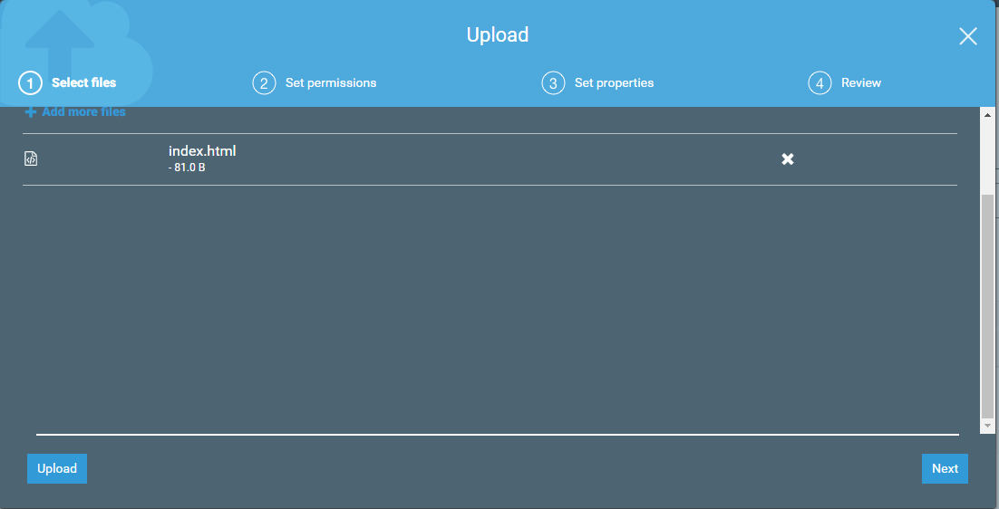

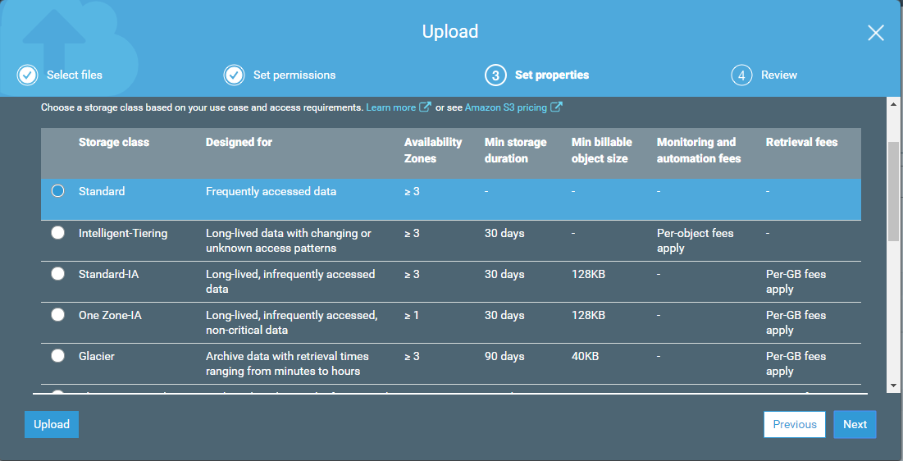

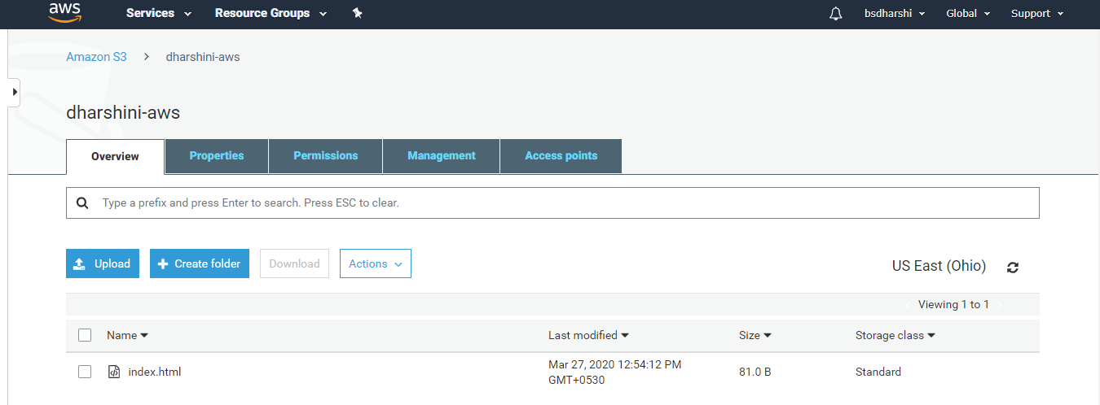

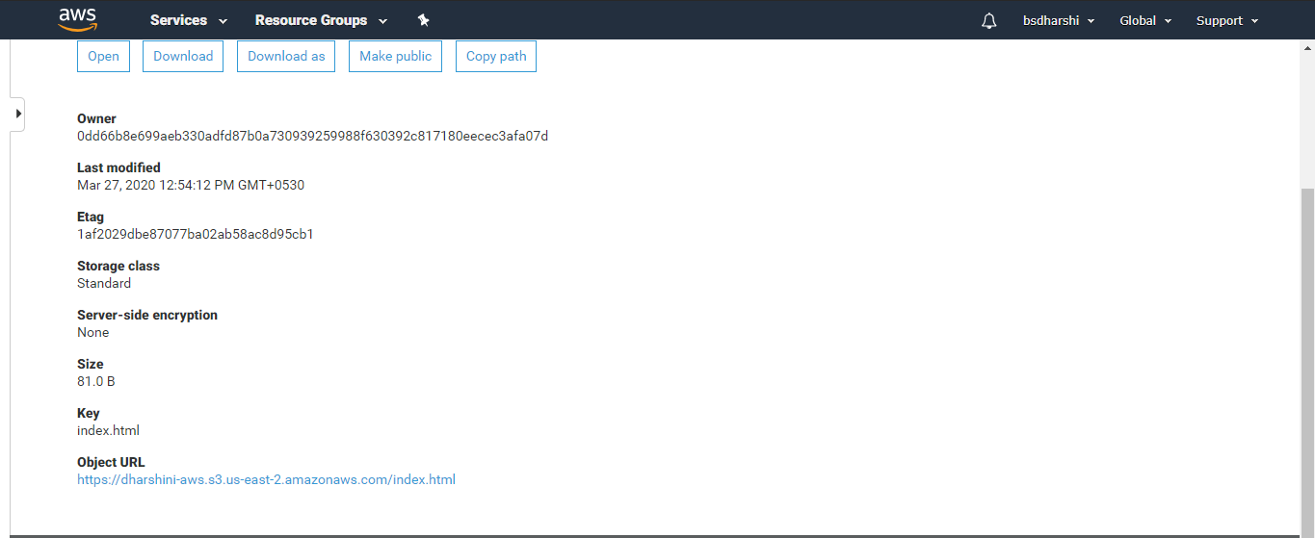

Step: 3 In property tab select static website hosting and enter the document name and save it.

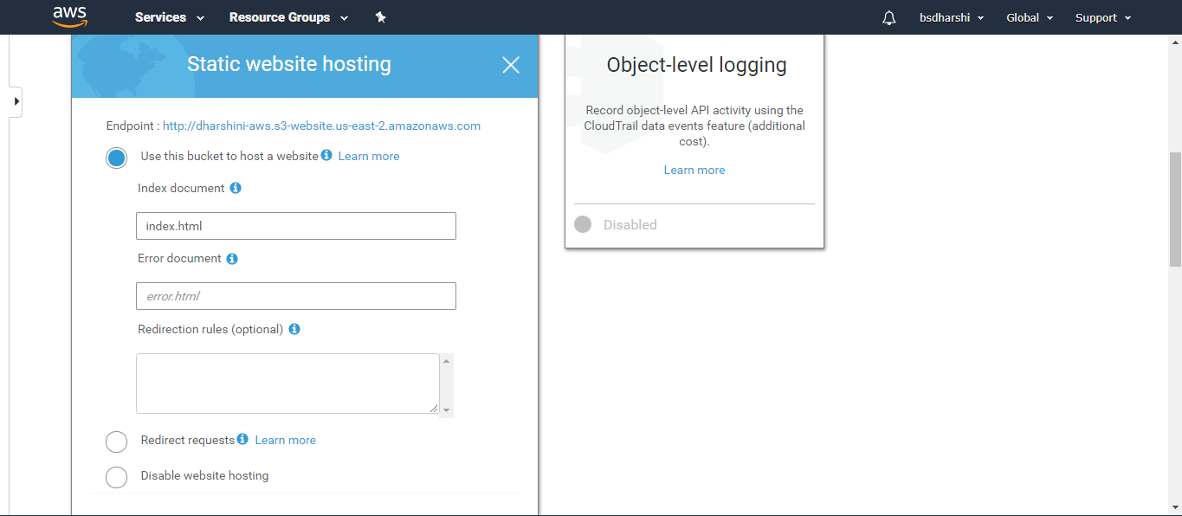

Step: 4 In permission tab off the block public access.

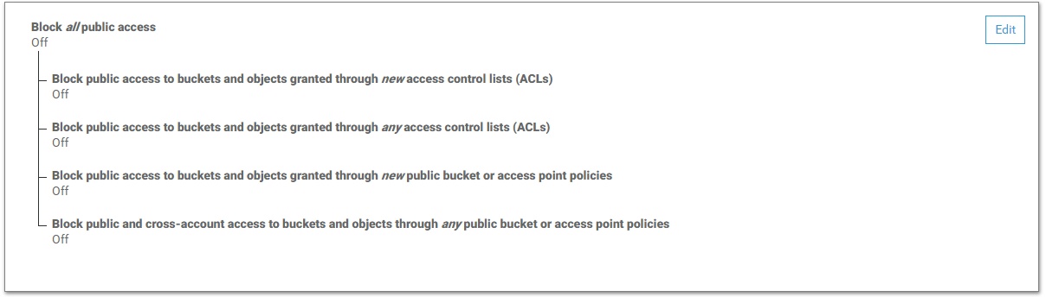

Step: 5 In overview tab make the object as public.

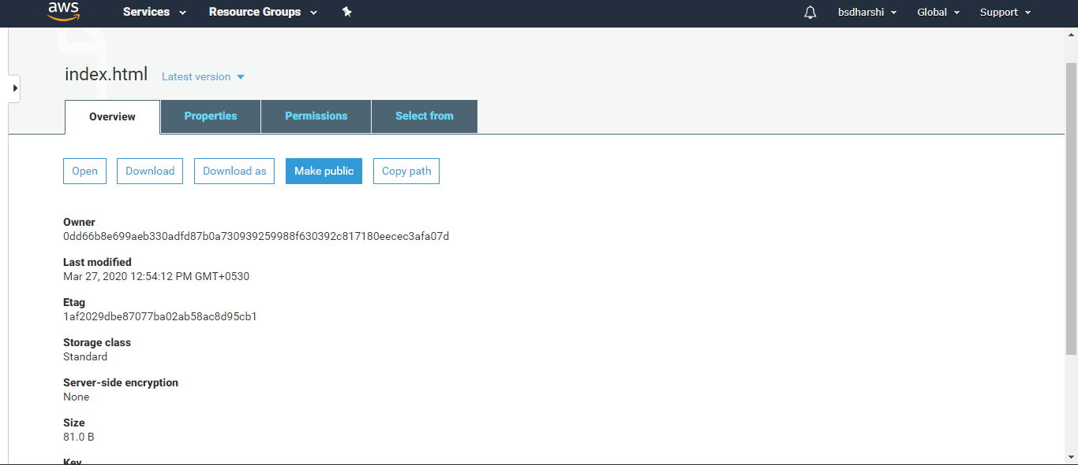

Step: 6 This is the website with url.

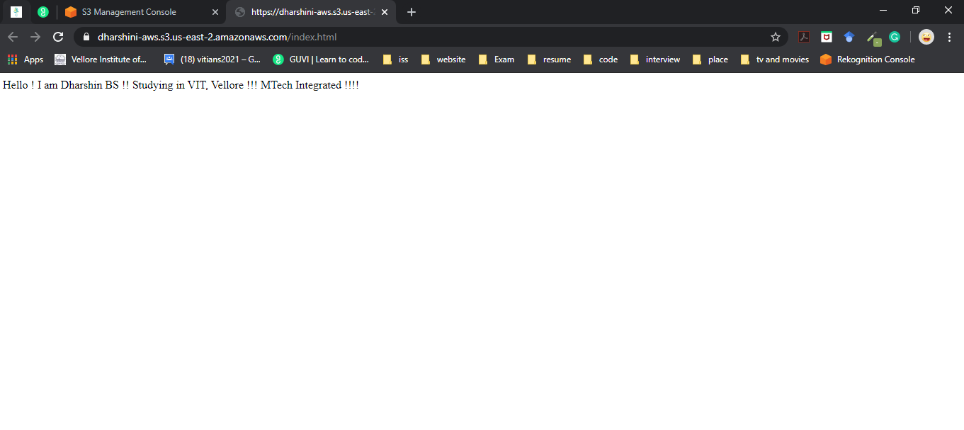

1. **EC2 and S3 Linking**

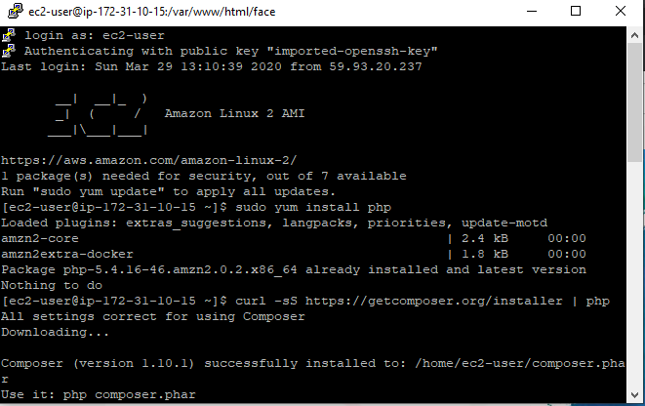

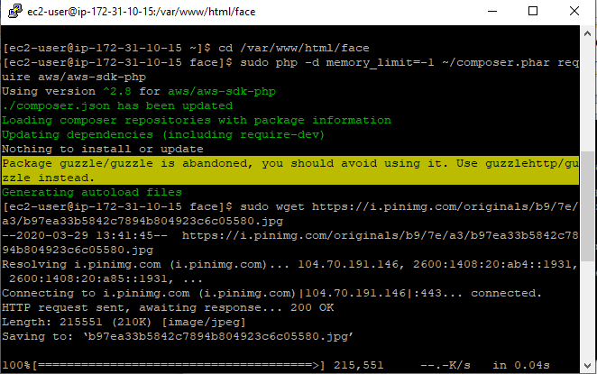

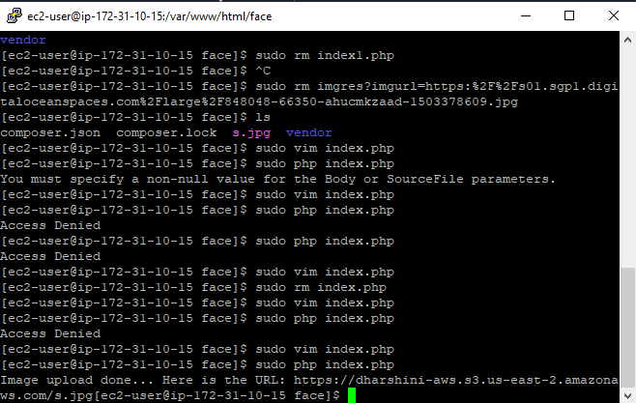

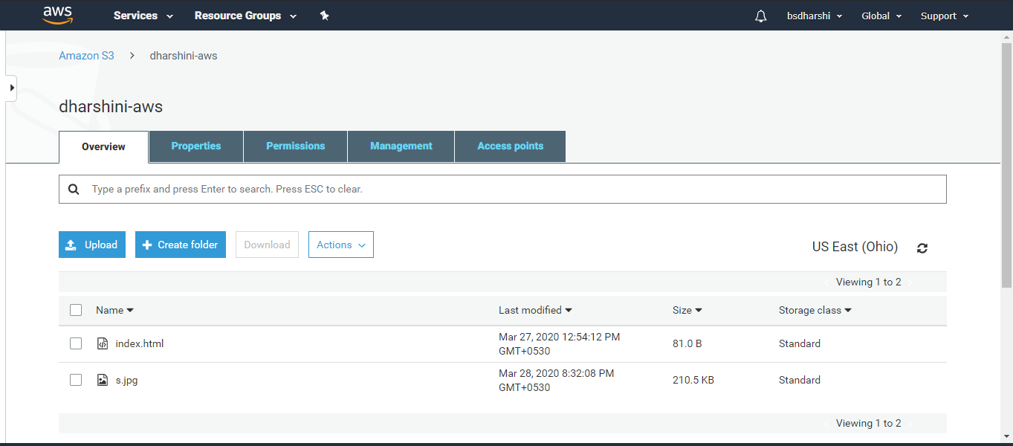

1. **Rekognition**

Face detection:

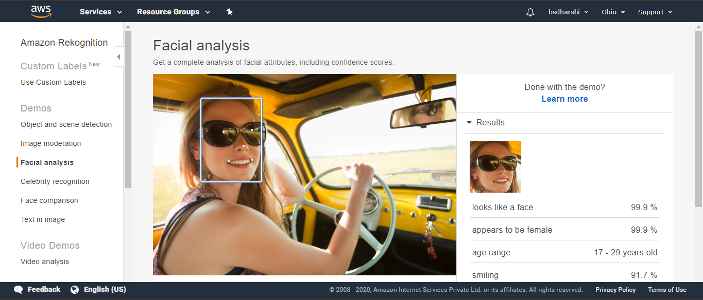

Face comparison:

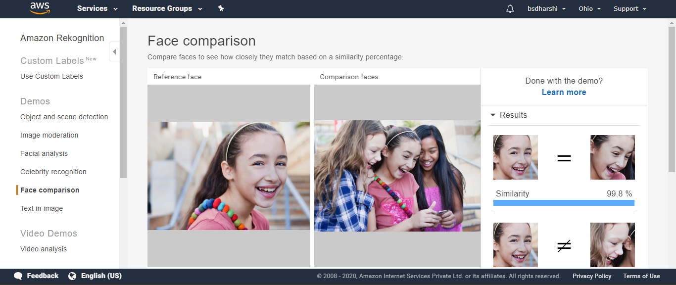

Celebrity recognition:

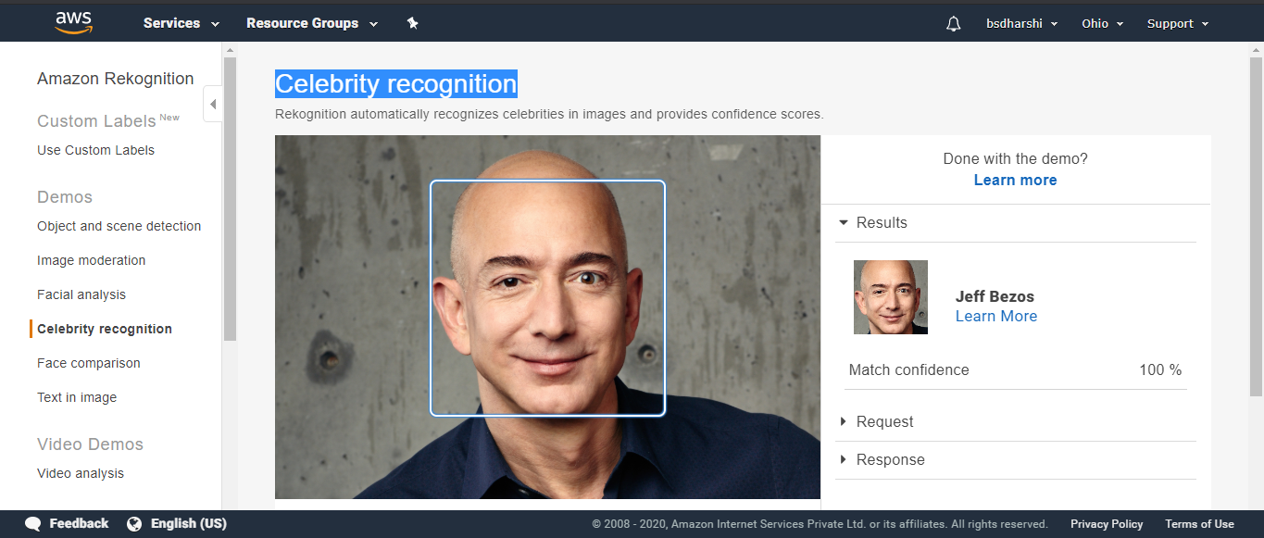

Text in an image:

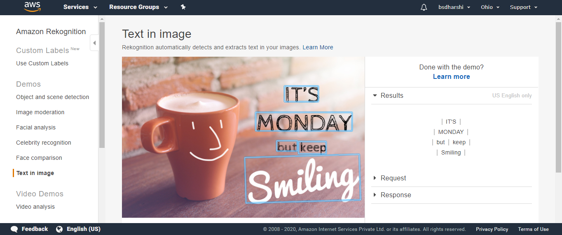

1. **Face detection success:**

